https://www.nasa.gov/smallsat-institute/sst-soa/thermal-control/#7.3.3

Current Experimental Method
12/ 19/ 2023 Research Updates
01/ 03/ 2024 Experimental Updates
01/ 17/ 2024 Updates
01/ 22/ 2024 Research Updates
02/ 07/ 2024 Final Material List
02/ 21/ 2024 On-Bench and Research Updates
03/ 05/ 2024 Updates
03/ 13/ 2024 Heat Source Research
03/ 27/ 2024 Updates
03/ 29/ 2024 Updates
04/ 03 / 2024 Updates
04/ 10 / 2024 Updates
04/ 17/ 2024 Updates (Bill of Materials)

Current Experimental Method
- Objective: Determine emissivity of E- Paper at various shades controlled via pixel density
  - Show 3 different pixel densities – 100% pixels, 50% pixels, 0% pixels, compare emissivities
- Schematic:
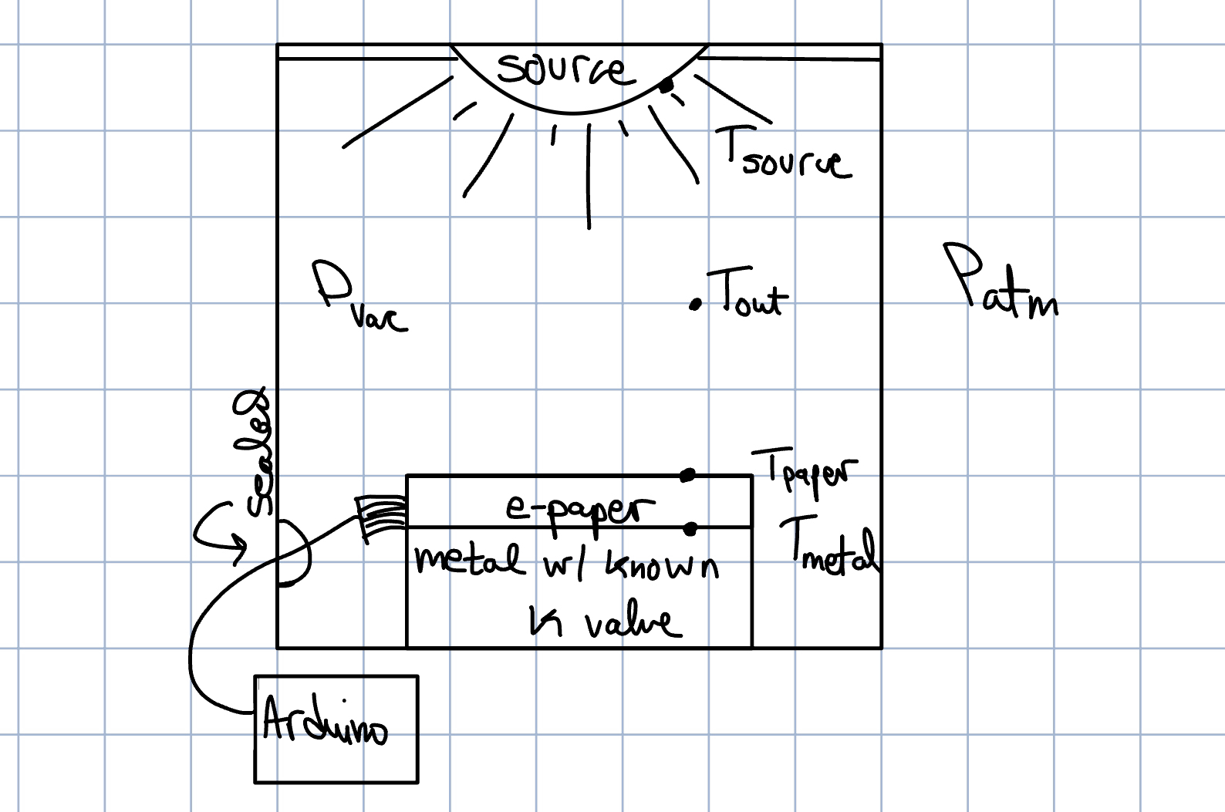

- Givens:
  - P_vac, L e-paper, W e-paper, k_metal, q_in, pixel density(variable) ,
  - Bill of Materials (THINGS WE NEED TO BUY!!!!!!!!)
      - ALL LINKS SUBJECT TO CHANGE, THIS IS JUST FOR ESTIMATING A BASELINE PRICE LEVEL
    - Heat Source: UV-IR light xenon arc lamp (for now, See Link for UV-IR source
    - Vacuum Chamber: for now (Vacuum Chamber)
      - LOOK INTO PAINT COATS TO REDUCE REFLECTIVITY OF VACUUM CHAMBER!!!
    - Metal: aluminum sheet
    - E- paper: 4.2 inch display (400x300 pixels)
    - Arduino/Raspberry pi

- Approach:
  - Fourier Law of Conduction: $q = -kA_{surface}ΔT$
  - Stefan Bolztman Law of Radiation: $q = ϵσA_{surface}*({T_{surface}}^{4}-{T_{source}}^{4})$
    - $0≤ϵ≤1$, emissivity, unknown
    - $σ$ is the Stefan Boltzman constant and describes the rate of
  - !!AT STEADY STATE conduction = radiation!!
  - Potentially: treat system like a circuit to help show model/ modes of heat transfer
- Secondary Approach:
  - Analyze transient response, suggested by sidebo (See 01/22/2024 update)
  - $Q = Q_{in }+\sum{}\frac{T_{j}-T_{i}}{ R_{ij }}$ (3)
  - Here, we can quantify and visualize heat transfer rate over time, could be extremely useful.
  - R unknown for radiation node, known for conduction node

12/ 19/ 2023 Research Updates
Questions to consider:
- How do we know where to measure the temperature of paper from?
  - We cant measure emissivity explicitly, measure temps instead (temp of surface and temp of source)
  - Behind e paper is conduction. If we measured temp on other side of aluminum, energy balance → heat transfer conduction = heat transfer radiation at equilibrium (indicated by constant temperature)
- Why does location of heat source not matter?
  - We are testing at steady state.
  - **There are several surface/radiation properties that influence heat transfer (reflection, absorption, emissivity, etc)
- Difference between radiation and other forms of heat transfer?
  - The difference between radiation and conduction/convection is that it can occur in a vacuum.
- What if pixel density changes reflection but not emission?
  - :D?

IMPORTANT CONCEPTS OF NOTE:
Can e-paper be a blackbody? Will we have Blackbody Radiation?
Blackbody: The perfect absorber and emitter
- A blackbody absorbs all incident radiation, regardless of wavelength and direction
- For a prescribed temperature and wavelength, no surface can emit more energy than a blackbody
- Although the radiation emitted by a blackbody is a function of wavelength and temperature, it is independent of direction. That is, the blackbody is a diffuse emitter.

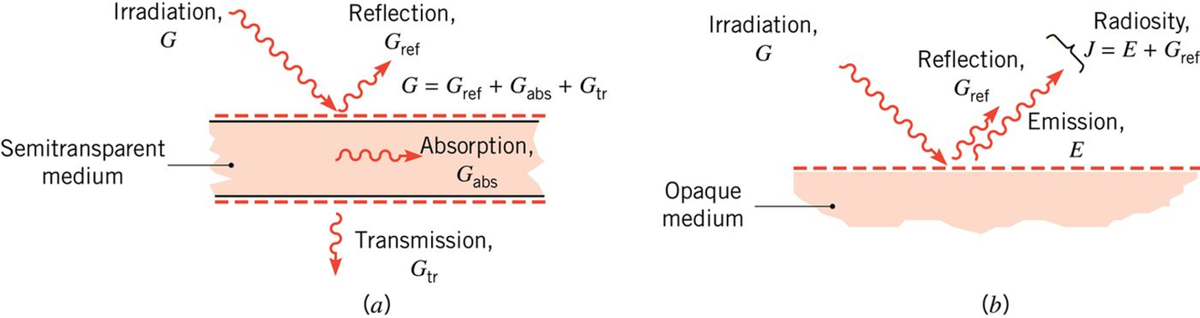
- Figure 12.4: Radiation emitted by a surface. (a) Spectral distribution. (b) Directional distribution.

01/ 03/ 2024 Experimental Updates
- Updated schematic for experiment.
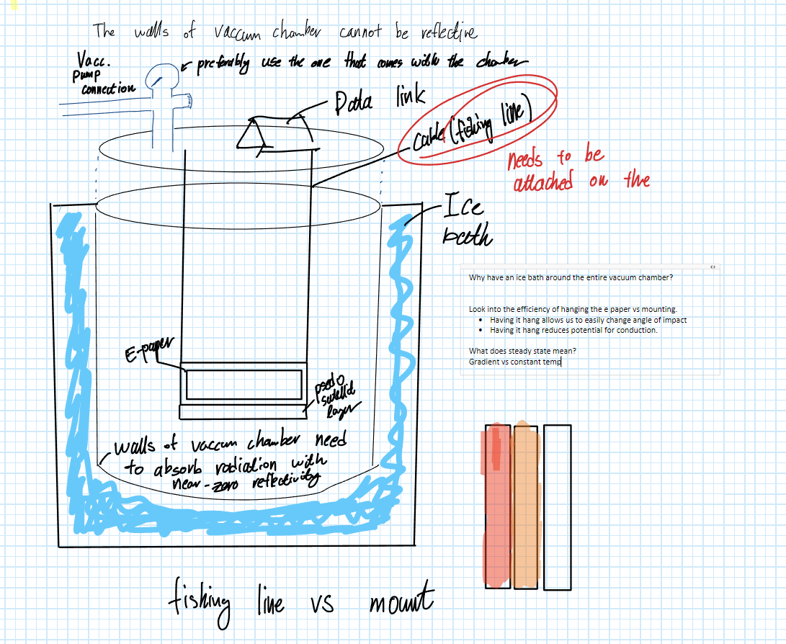
- Changes of note:
  - Hang e paper/aluminum with fishing line instead of mounting to bottom
    - Reasoning:
      - Easily change angle of impact
      - Reduces potential for conduction with vacuum chamber
  - Surround vacuum chamber with ice bath:
    - Reasoning:
      - Isothermal layer
  - Determined necessity to coat inner layer of vacuum chamber with black paint
    - Reasoning:
      - Walls must absorb radiation with near- zero reflectivity

- “Meta” Method (not set in stone, general idea):
- Fasten aluminum to e-paper, fasten thermocouple to e-paper/aluminum interface. Fasten another thermocouple to top surface of e paper and another one to the bottom surface of the aluminum
- Fill bucket bottom layer with ice, place vacuum chamber in the bucket, surround remaining space with ice and water.
- Feed fishing line through top of vacuum chamber. Fasten lid of vacuum chamber and seal holes before removing air from chamber.
  - Ensure no leaks by watching pressure gauge. If leaks, find source or repeat 3.
- Turn on UV/IR light and note changes in temp at the different data points over time. Monitor temperature of surrounding ice bath to ensure isothermal layer remains isothermal
- When steady state is reached, note the temperatures of the interface, bottom aluminum, top e-paper, and source. These are the known variables of the radiation and conduction equations. We can find epsilon by comparing these two modes of heat transfer, assuming any other mode of heat transfer is minimal compared to radiation (negligible).

01/ 17/ 2024 Updates
- Changed objective from “Determine emissivity of E- Paper at various shades controlled via pixel density” to “Quantify the fraction of energy absorbed by the E-paper at various pixel densities during radiative heat transfer”

01/ 22/ 2024 Research Updates
- Is the satellite in the shadow of the earth? We can't have a controlled environment in space.
- Will an ir/uv lamp simulate solar well
  - Let’s use the actual solar light as an input.
  - pyranometer
  - Potentially have both a laboratory model and outside model
    - Transient vs steady state
  - Estimate whats collected and how much of it raises the temperature? Not sure what he meant here.
  - Vacuum chamber for simulating heat loss, ie:
    - Bring it outside, let it heat, bring it to vacuum chamber and let it cool down.
  - Let room temp be the isothermal layer
  - “Separate solar source from thermal” -sidebo
  - Infrared heat lamp may not be a good representative of solar energy
    - If we were to do this outside, how to quantify heat loss. If we bring it outside and then cool it down how do we know what is happening.

02/ 07/ 2024 Final Material List
- Materials
  - Vacuum Chamber (1)
    - Black Paint (1)
    - Fishing Line (1)
  - MCP9600 Thermocouple Amplifier (6)
    - Operating Voltage Range: 2.7V to 5.5V
    - Operating Current: 300 µA (typical)
    - 0.99 - 1.65W
  - Type K Thermocouples (6)
  - E-paper (1)
- Currently waiting on arrival, parts ordered
- GOAL: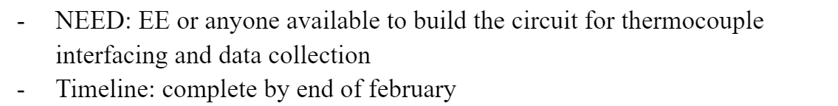

02/ 21/ 2024 On-Bench and Research Updates
- On-Bench Updates
  - Waiting on black paint, haven't ordered lamp yet, looking into xenon arc (mimics wavelengths emitted by sun)
  - Built DAQ circuit (based on Brandon Bunt LHCM experiment, see github here)
  - 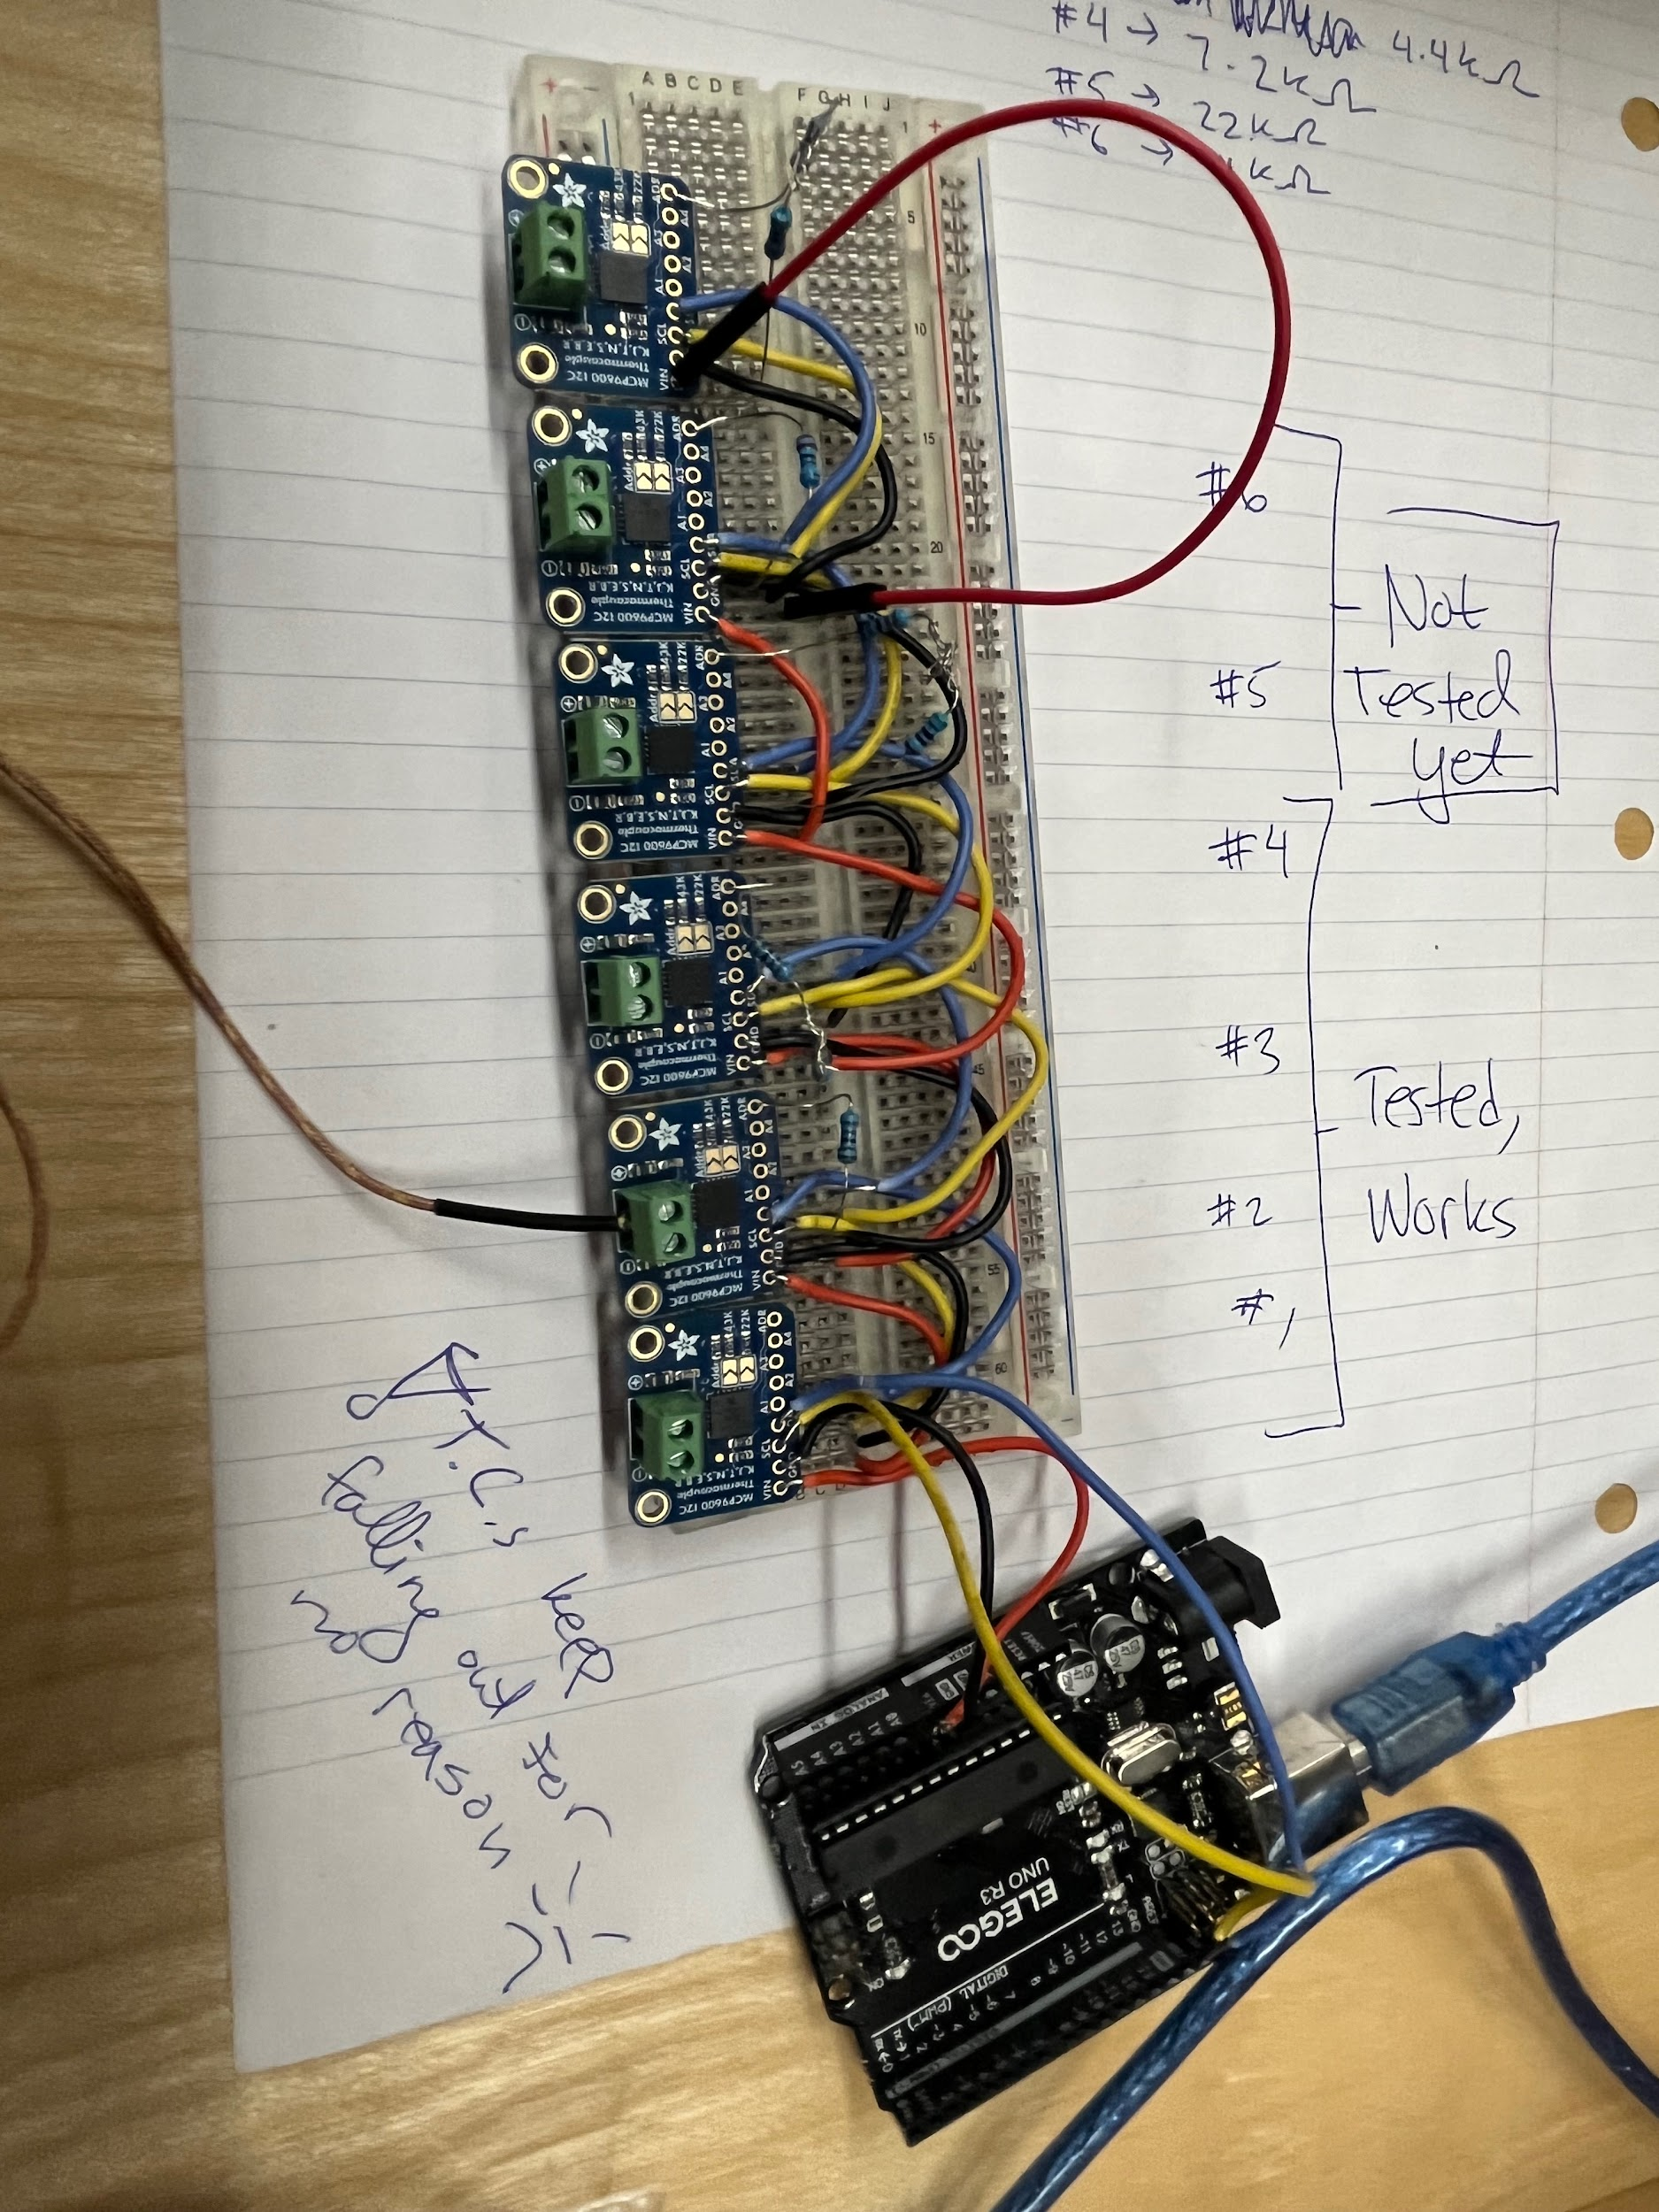
  - Tested TCs 1-4, readout accurate! 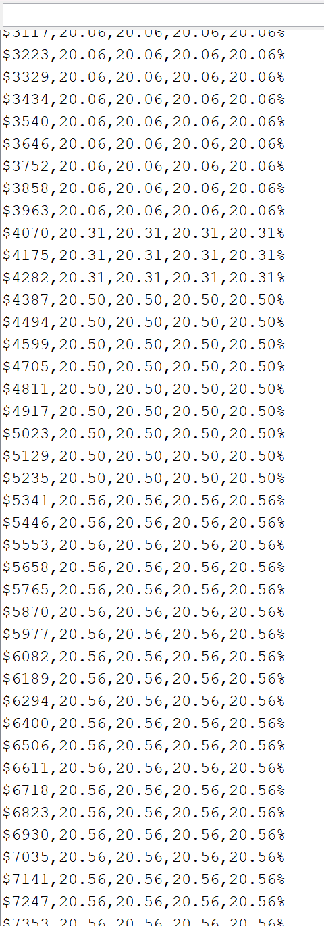
(time (ms), T1, T2, T3, T4)
  - I will add circuit diagram later…
    - Pulldown resistor values:
TC2 ->2.2k (address to ground)
TC3 ->4.4k (address to ground)
TC4 ->7.5k (address to ground)
TC5 ->22k (address to ground)
TC6 ->44k (address to ground)
- GOAL REACHED!!:
- NOTE: THERMO
S FALL OUT WITH MINOR MOVEMENT, BRAINSTORM WAYS TO PREVENT THIS!!!!!
- Code: *i will upload to git and link here after i improve the interface*
- Thermal Circuit 2 Node Model:
  - 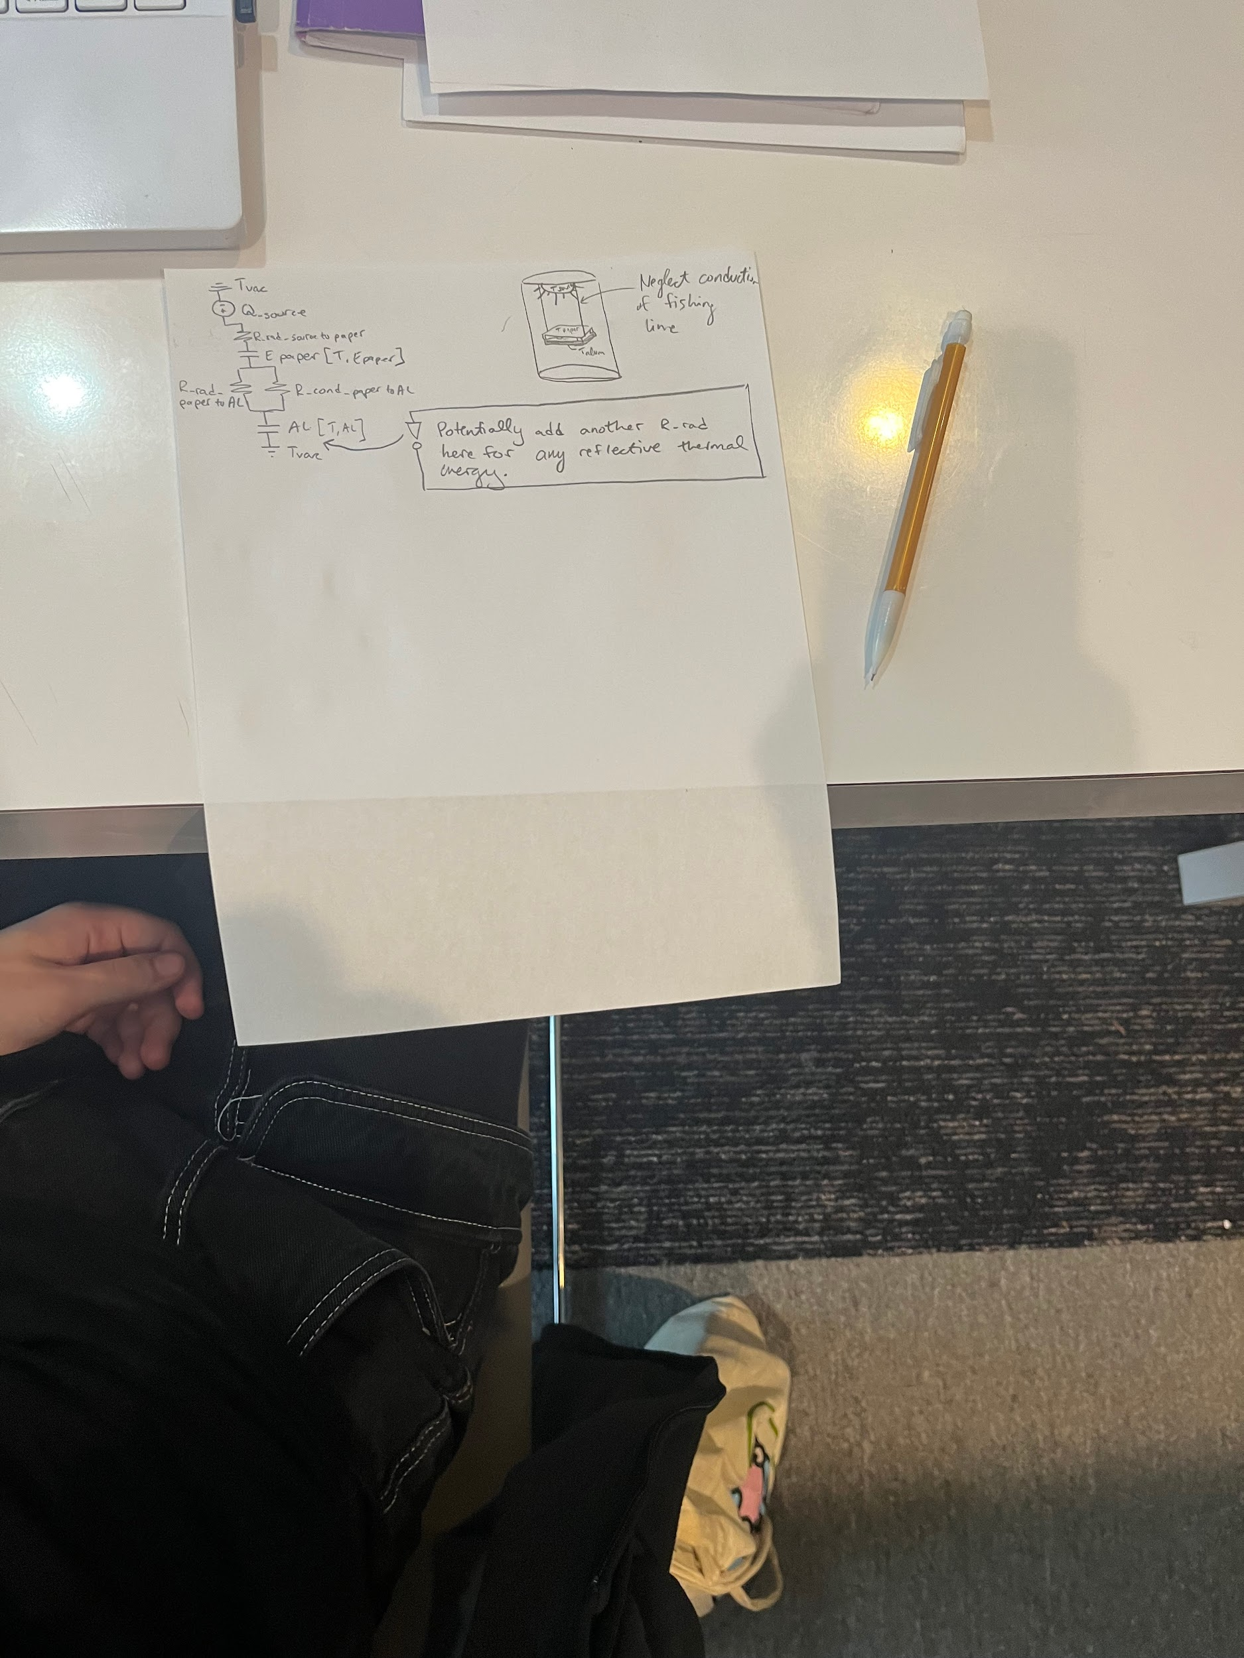(developed by Isabella and Gaudi)
  - The goal is to QUANTIFY heat transfer as a fraction of ENERGY ABSORBED VS REFLECTED (see image in 12/19/2023 update).
We noted that this may be difficult to solve because there must be conduction occurring between e paper and aluminum as well as radiation and BOTH thermal resistances are unknown. However, we can likely assume conduction based on the materials present in e-paper. Then, the only unknown is radiation. We can solve for radiation with equation(1) and use this to quantify and visualize Q between the 2 materials! **discuss this with profs**

- Sidebo made an N-node model of what we are doing here, we should ask if his model can be used for an unknown emissivity. Otherwise, his model matches ours. (meant to predict behavior)
  - His model predicts that given WOOD, it takes 30 minutes for the backside of the wood to change temperature. How does this compare to our thermal properties? Could give us insight into how long OUR experiment will take.
  - Radiative component is surface temperature dependent.
- Potentially: comparing epaper experiment alone and e paper w/ Al backing
  - Potentially: FAE model of experiment (to help estimate surface temperatures)

03/ 05/ 2024 Updates
- Option 1 (Thermal Energy from Sun, cool down model)
  - Parallel thermal circuit, wait until the paper reaches some temperature, explore the cool down behavior
  - Pros: Thermal energy source is same as will be in space, may be the best possible characterization of the system.
Cons: The heat up may be much longer than desired, considering convection and distance of sun from earth during March (weak UV).
- Option 2 (Thermal Energy from Xenon Arc, Radiative)
  - Parallel thermal circuit,
  - Pros: seamless,
Cons: may be the most expensive option
  - Xenon Arc Bulb ($400)
Adapter ($170)
- Option 3 (Thermal Energy from Xenon Arc or similar, Steady State Q_conduction = Q_radiative)
  - All known except radiative coefficient, series circuit

Questions:
- Possibly interpolating the surface temperatures for radiation equation (Option 2)
- Prof Wright agreed that Option 3 may be the best option. We can interpolate surface temps using the same concept as we used in Experimentation where all is known (K, T1, T2, A, z) except Q. Temperatures are collected close to the surface.
- We may need to collect surface temperatures manually. This can be done, however, after we officially reach steady state conduction.
- What exactly is E-paper?.

03/ 13/ 2024 Heat Source Research
- 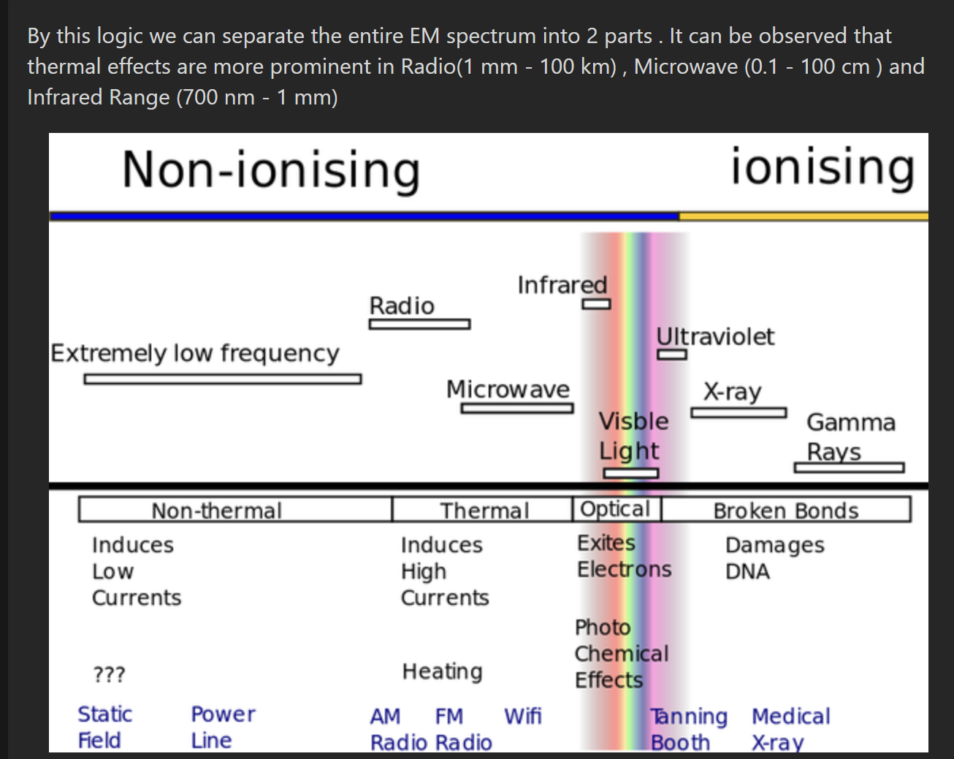Seems like IR will have greater thermal impact
- 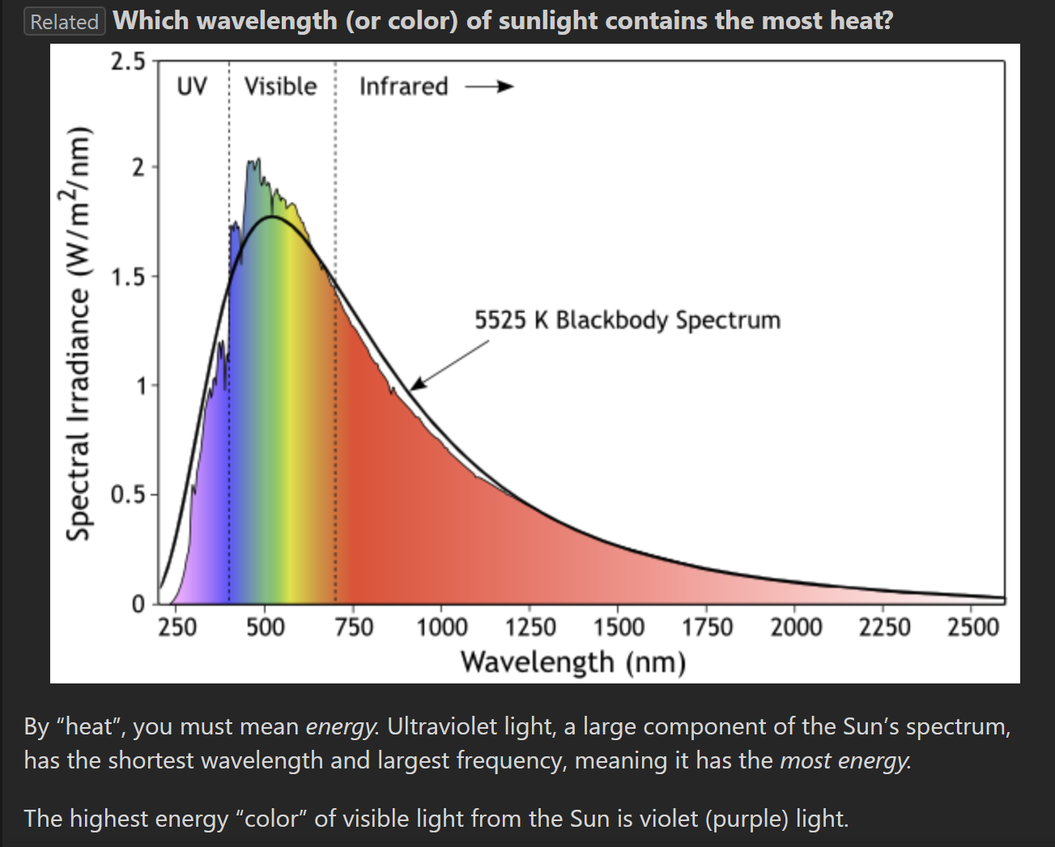 However, UV releases more energy than IR
- 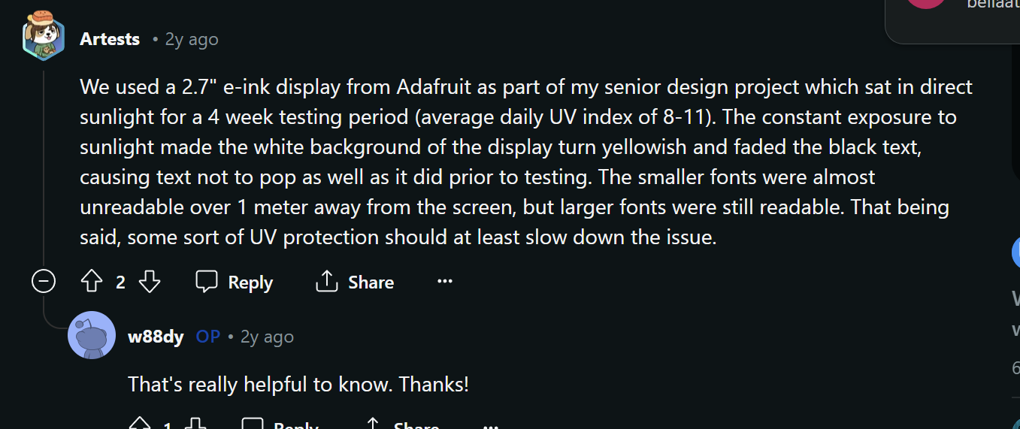 This is an idea from reddit that was similar to our application of the e paper in direct sunlight – looks like we will be ok as long as we dont prolong usage
- How do Xenon-Arc Lamps Work

03/ 27/ 2024 Updates
- Received paint, planning to have inside of vacuum chamber painted by end of week
- Options for feeding electronics outside of vacuum chamber:
  - Cut hole in top
    - Use a silicone sealant
    - Maybe do one of these guys(gasket)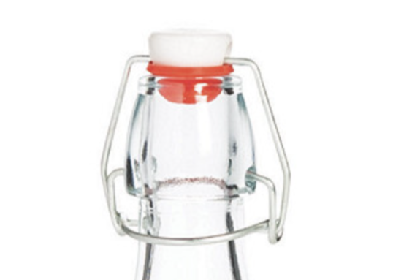keep it as airtight as possible with the limitations of budget and thickness of the lid (would be really sad if we can establish a vacuum)

- Options for Light Source (cant be inside chamber)
  - Optically transparent at UV wavelength??? Quartz? IR Transparent Materials
  - Maybe run experiment outside to get idea of how this thing will behave (in prep for controlled environment)
- Brainstorm ways to prevent thermocouples from falling out
  - Potentially: epoxy resin
  - Potentially: solder ends to thicker wire
    - Problem: the voltage drop between different materials is what gives us the temperature difference
  - Potentially: add U shape wire connectors to ends instead

03/ 29/ 2024 Updates
- Current problems and proposed solutions and timelines
  - Running electronics out of lid
    - BY SUNDAY: CAD the lid, new holes, and a fastening using an O ring and nut and bolt system to help re-establish airtight-ness of the lid, order necessary components
      - Then we will be able to get it cut by sinisia next week
  - Source Problem(s):
    - Potentially: add another hole in lid for a UV/IR transparent material
    - PROBLEM: scientific quartz windows are like $3k
    - Potentially: look into a space heater application instead (radiative heat)
      - I don't think this works for our application, but it may produce similar/comparable results
    - Safety hazard associated with using Xenon Arc:
      - We may have to build a casing in case someone decides to stare at an extremely strong light for no reason
        - Or we can conduct it in a chemistry lab that is not in use
  - Paint problem:
    - Research thermal paints
  - Finish thermocouple circuit by end of week, ready for testing by end of week

04/ 03 / 2024 Updates
- Met with sinisa, he suggested we use hex bearings/ npt fittings.
  - Look into feed through fittings
  - UPDATE mike gave me a wire gland I am gonna use that

04/ 10 / 2024 Updates
- Turns out my circuit was poo poo garbage.
  - Spent weekend fixing it – problem was i connected the chips to each others address w/ resistor instead of connecting chip ground to address w/ resistor
    - Found out that the address of the data is directly related to the value of the resistor, not really sure why
  - Also soldered lower gauge wire to the thermocouples, now the amplifiers clamp them much much better!!

- Jay showed me this thing in signals called absorption/scattering coefficients, can we potentially use this to avoid putting any more holes in the acrylic lid??

- Why Xenon Arc?
- https://coopersat.my.canva.site/

04/ 17/ 2024 Updates (Bill of Materials)
Spoke to Tiffany briefly about what patterns we will work with for preliminary testing, will eventually work on integrating waveshare and amplifier circuits and codes, but for now we can just run separately.

This week was dedicated to finalizing the bill of materials for the experiment. The following links are some videos I watched to help familiarize myself with solar simulators/ what specs are desirable as well as some simulators I viewed.

1. Familiarizing
How to Choose Solar Simulators for your needs!
Typical Solar Simulator Setup
Types of Solar Simulators and Info on Ratings
XENON Solar Simulator Setup

2. Options
Xenon SS AAA rated, good specs, $8.5k yeowwch (literally JUST outside our budget :( )
Another Xenon SS AAA rated good specs, pricey pricey pricey
LED SS Option AAA rated, good specs, insanely expensive

Link for super cheap Solar Simulator Ended up purchasing this one, super cheap, AAA rated for a relatively small distance and diameter, will work for our purposes but kind of limits us distance wise

As for pumps: 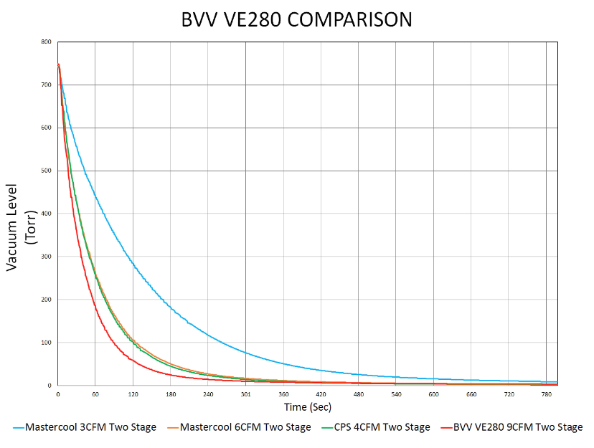
This is the vacuum vs time graph from the same company that sold us the vacuum chamber – we decided that we can choose any pump with a flow from 4- 12 CFM, but considering the fact that we are likely going to have a leak from the wire feedthrough we decided that the extra money for a 9CMF pump is worth it!

ALSO
Mike gave me wire glands, these are a super low cost version of the feedthrough and they do the exact same thing, so I plan on adding a counterbore hole in the lid bc the tail end of the gland is kinda short….
Otherwise, i plan on actually running this with either sunlight or full spectrum light as soon as we get the pseudo satellite layer (copper sheet), this will likely be next week
Because we dont have a window for the lid yet, but we know that the acrylic is IR transparent, I will theoretically solve for how much light passes through using modern physics
ALSO every time i go to the machine shop, there is a class or they are backlogged so sorry about that … I flopped.

